**Helpdesk Jira Connector User Manual**

**Jira Interface :-**

**Step 1 :** Create a project in Jira by clicking on the create project button.

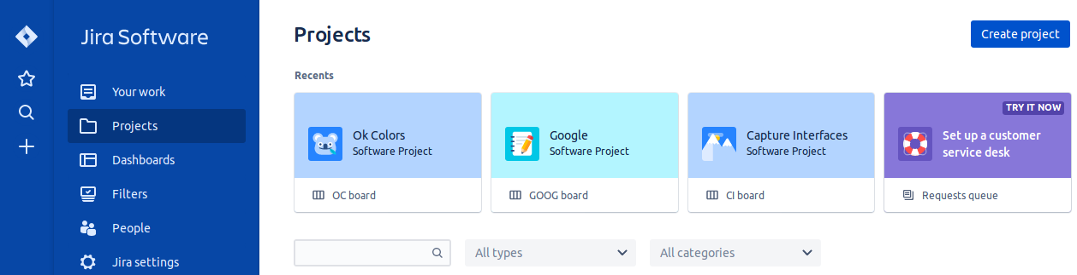

**Step 2** : Enter details for creating projects.

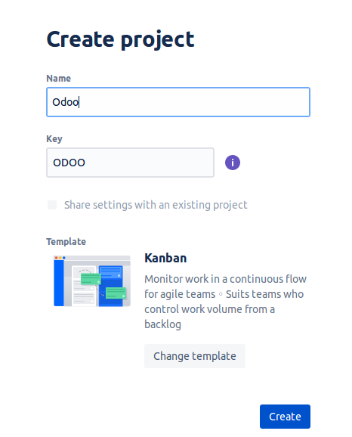

**Odoo Interface :-**

**Step 3 :** Sign In to Odoo Admin Account -> Go to Settings -> Companies Jira Configuration which allows following operations:

For Jira Token Generation follow these steps :

Go to <https://confluence.atlassian.com/cloud/api-tokens-938839638.html> as shown below.

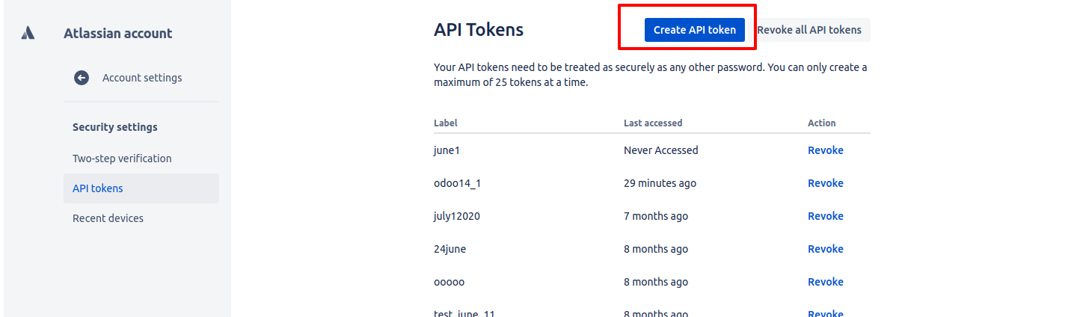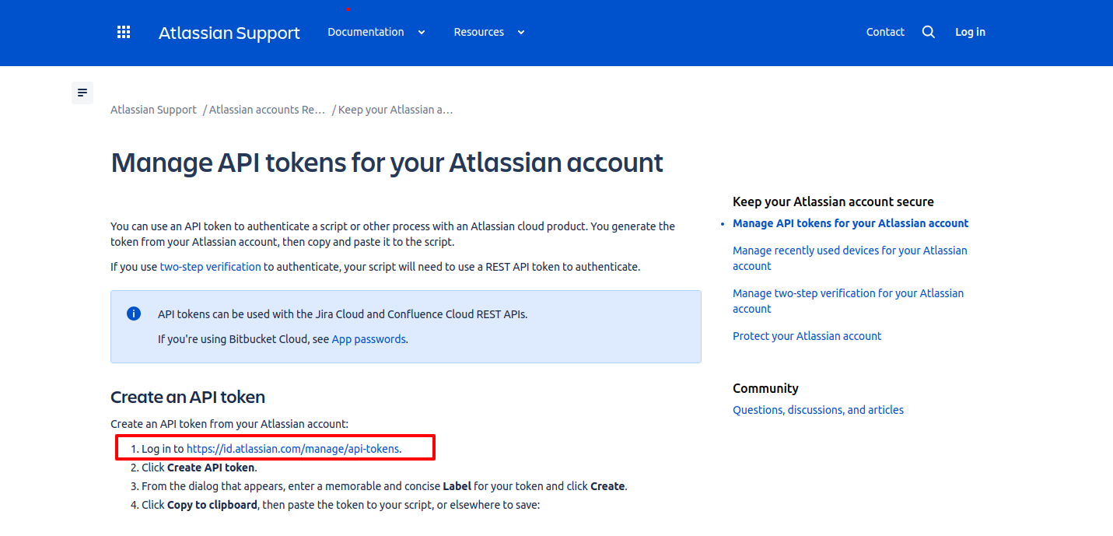

|  |
| --- |
|  |

Enter the Instance URL , Jira Login(Email ID) , Jira Token as shown below**.**

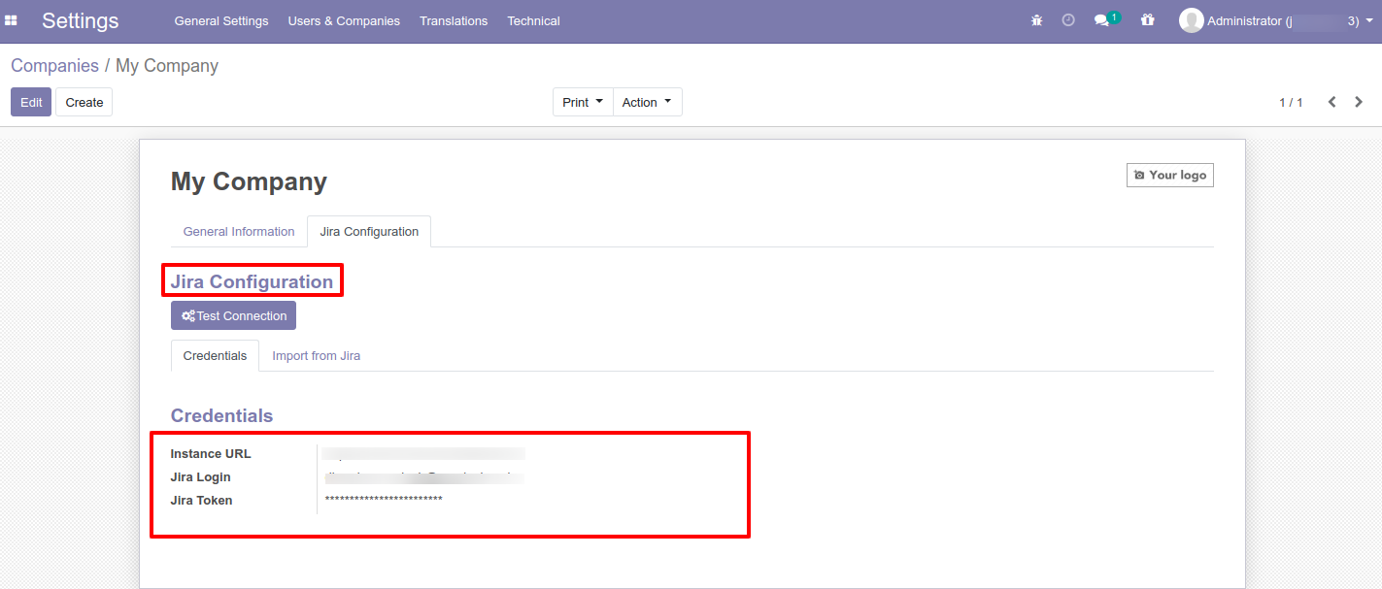

Once all the details are entered, click on “Test Connection”. If Authentication is successful then below message will come

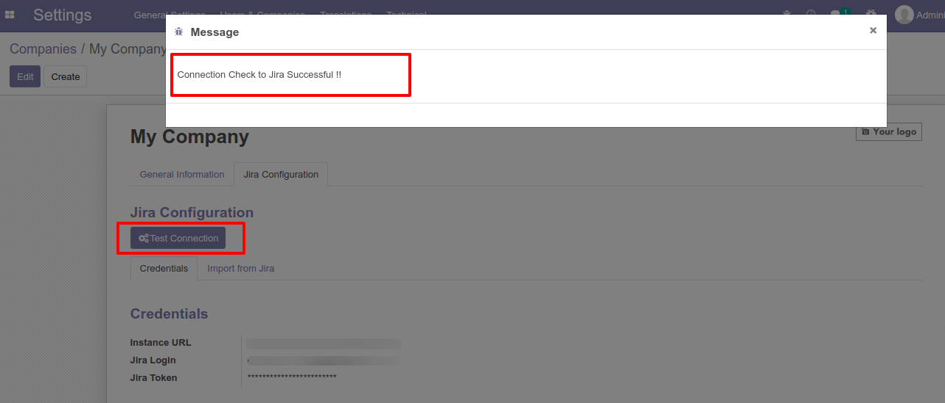

**Step 4**: Import from jira and click on the import project button.

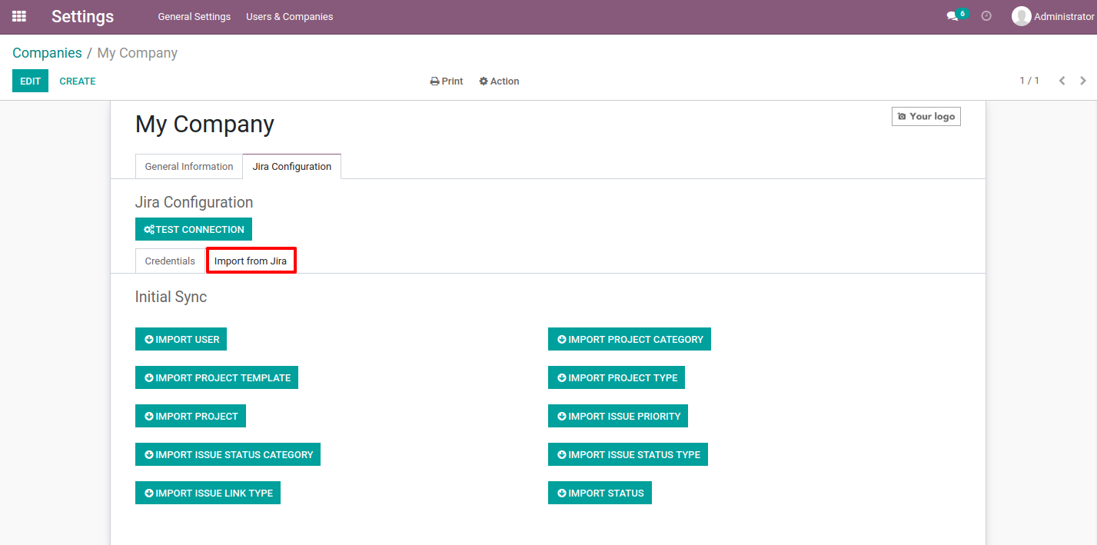

**Step 5**: For Export tickets to Jira follow shown below screenshots.

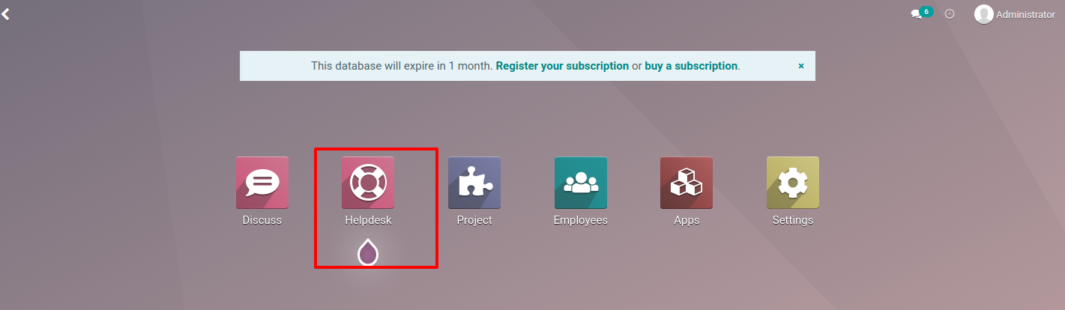

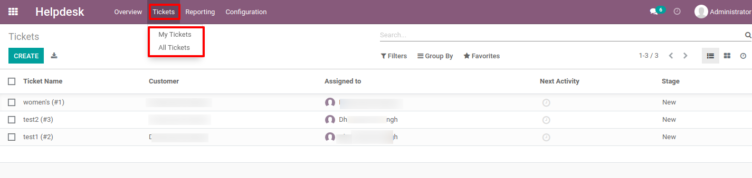

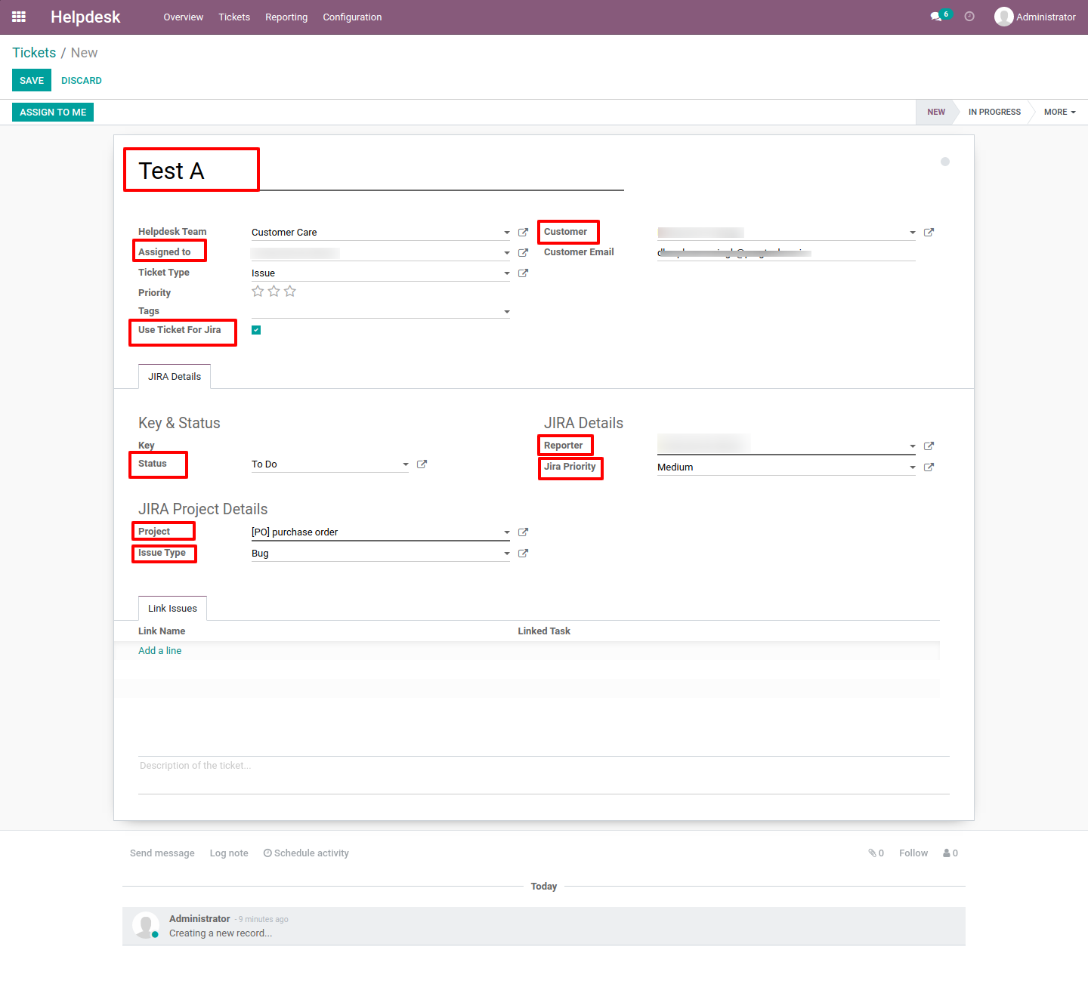

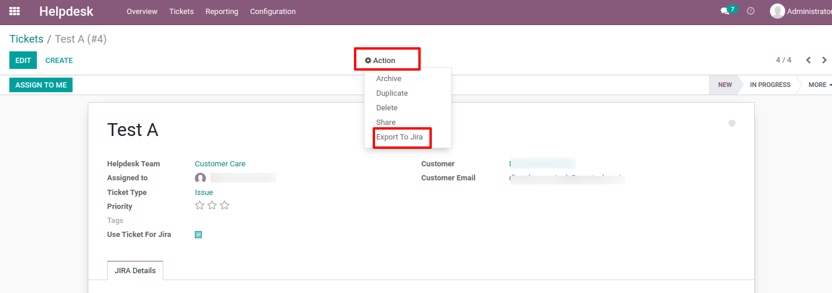

**Step 6** : Users can also import/export the following above mentioned details automatically by using cron as shown below.

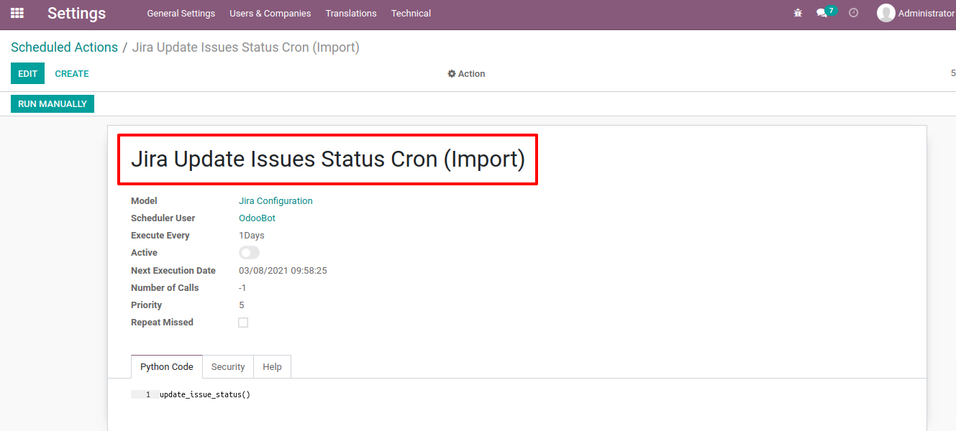

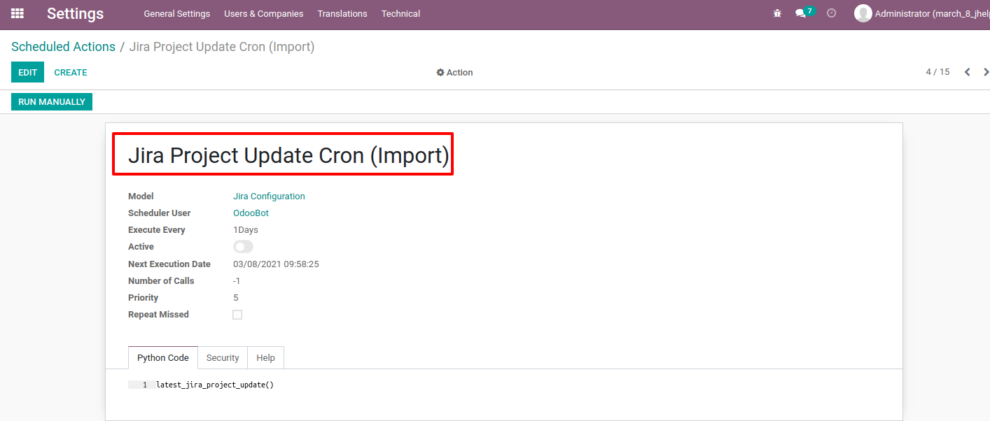

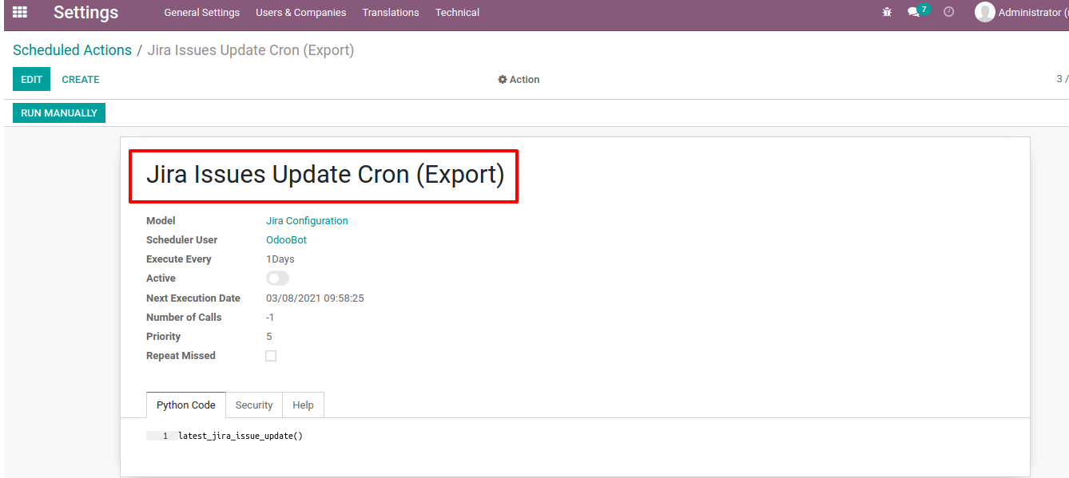

**Note** : Following are ways to set priority at Jira Account.

1. Go to Jira Account Open Any Jira Project, Then Click on any Issue related to that project.

2. On the Issue click on " Configure ", As screenshot is given below.

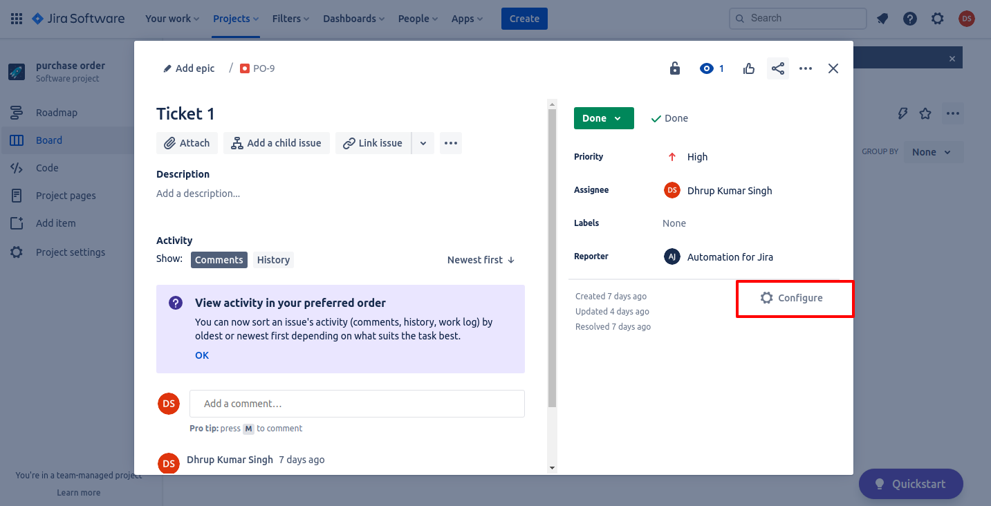

3. On the Configure page, There is Priority Option-click on that. It's going to be set for that project. Follow screenshot.

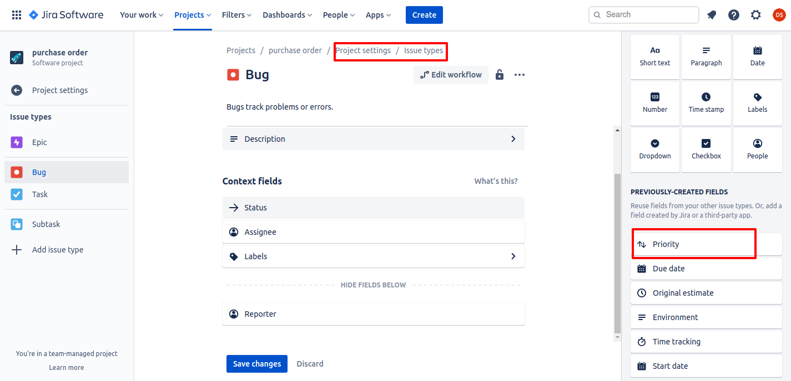

==================== End of Document ==========================